****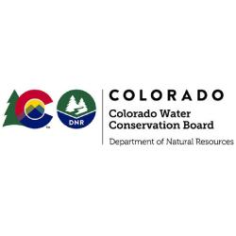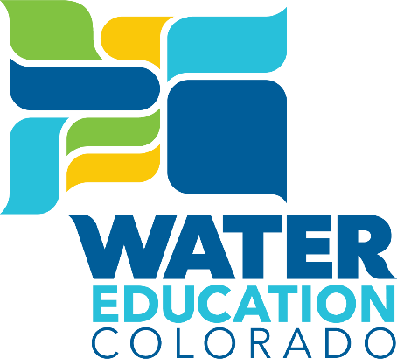

**Legislative Water Workshop**

**Turf Replacement and ColoradoScaping**

**April 16th, 2025**

**12:00 – 12:45pm**

**Colorado State Capitol Room 352**

*This educational session will offer a discussion on outdoor water conservation efforts including work done on turf replacement by the Colorado Water Conservation Board (CWCB) and the ColoradoScape work done by Castle Rock Water*

**11:45am Coffee and Snacks Available for Legislators**

**12:00pm Call to Order and Welcome**

*Representative Karen McCormick*

**12:05pm****ColoradoScape and Castle Rock Water Conservation Efforts**

*Mark Marlowe, Director, Castle Rock Water*

**12:25pm** **Overview of CWCB Turf Replacement Efforts**

*Jenna Battson, Outdoor Water Conservation Coordinator, CWCB*

**12:45pm Adjourn**

*Representative Karen McCormick*